**Lab- 1A: Creating and Running Virtual Machines on Hosted Hypervisors**

**Objective:**

To create and run virtual machines on hosted hypervisors such as KVM, VMware Workstation, and Oracle VirtualBox.

**Lab Outcomes:**

1. Install, configure and use hosted hypervisors.

2. Deploy and manage virtual machines.

3. Configure virtual machine settings.

4. Evaluate the performance of virtual machines on hosted hypervisors.

**System Requirements:**

- Host machine with sufficient resources

- Installed hypervisors:Oracle VirtualBox

- ISO images of operating systems for VM creation

**Step-by-step Procedure:**

Step 1: Installation

- Install Oracle VirtualBox:

Download and install VirtualBox from the official website.

Step 2: Creating Virtual Machines

3. Oracle VirtualBox:

- VirtualBox VM Configuration Screenshot:

![VirtualBox VM Configuration](path_to_virtualbox_vm_configuration_screenshot)

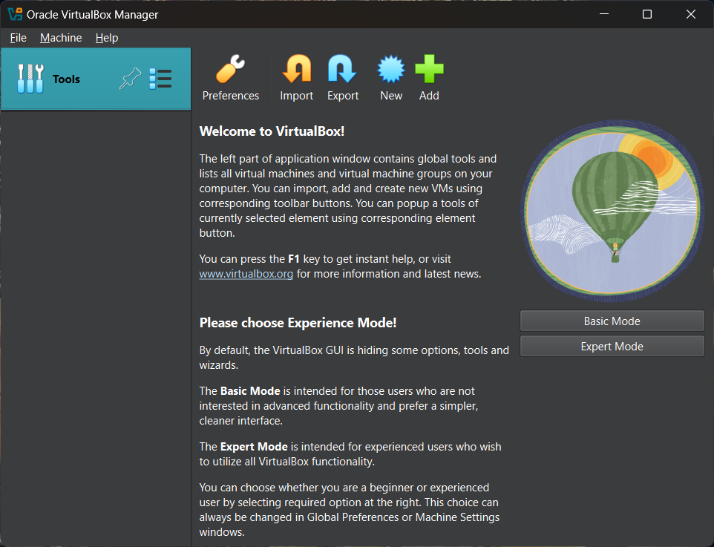

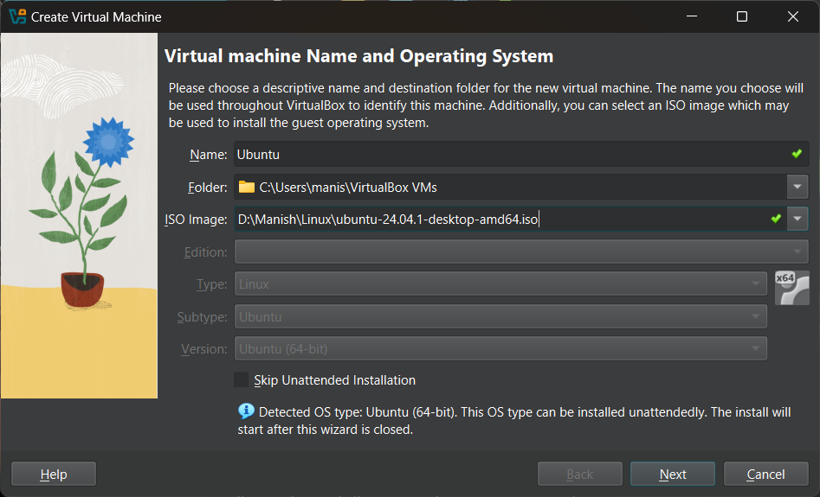

1. Name your Virtual machine and OS. Select the ubuntu iso file downloaded from ubuntu.com and select type as linux, subtype as Ubuntu and version as Ubuntu(64-bit) and click next.

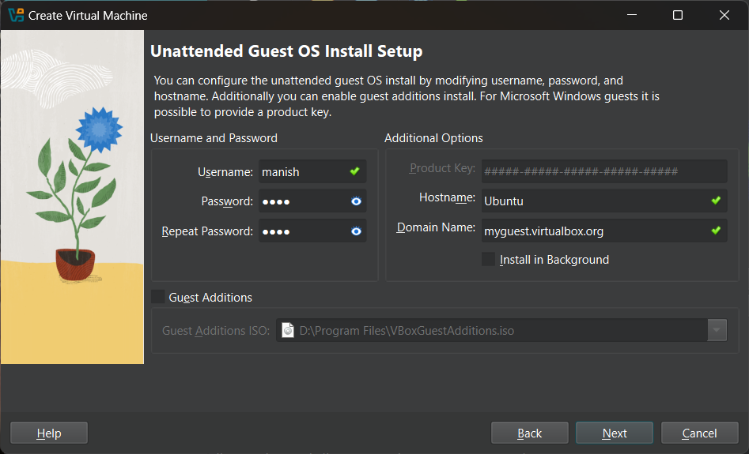

1. Change the password if you want to. And click next.

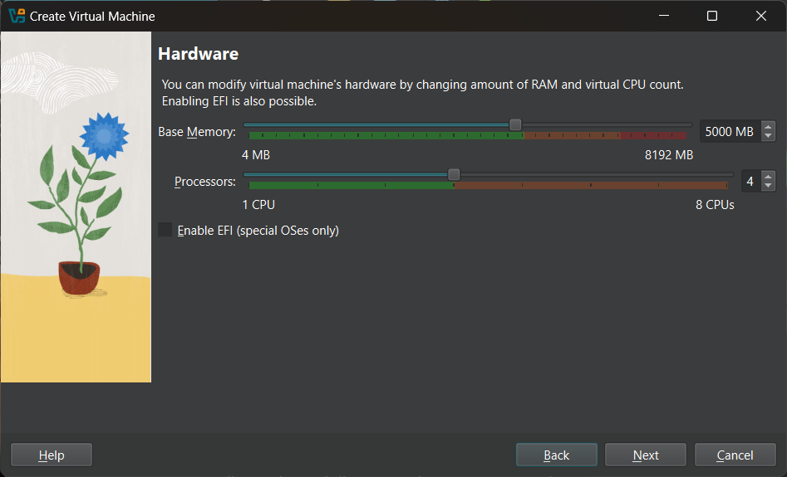

1. Select 8000MB(8GB) of RAM and 4 Processors.
2. Allocate 25 GB as hard disk memory

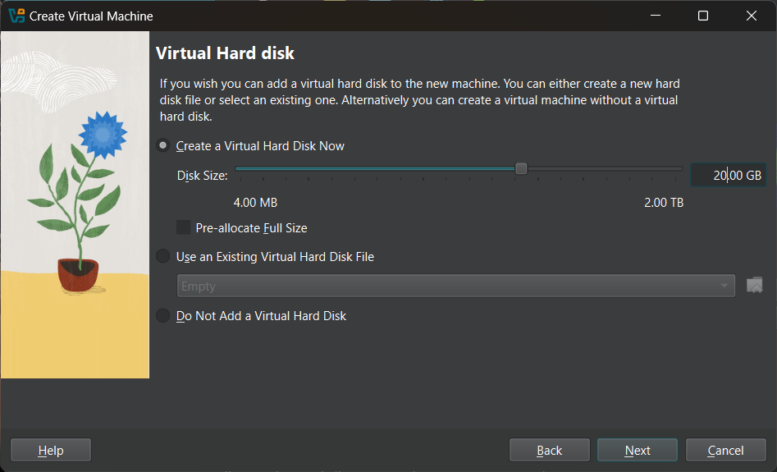

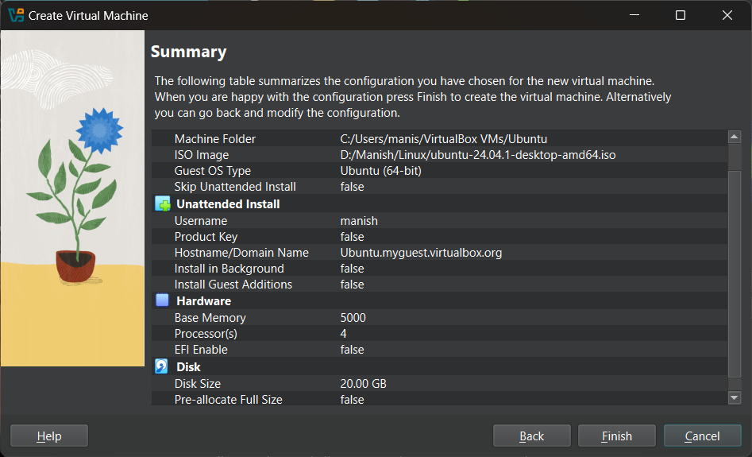

1. Click finish and follow ubuntu instructions and install ubuntu.

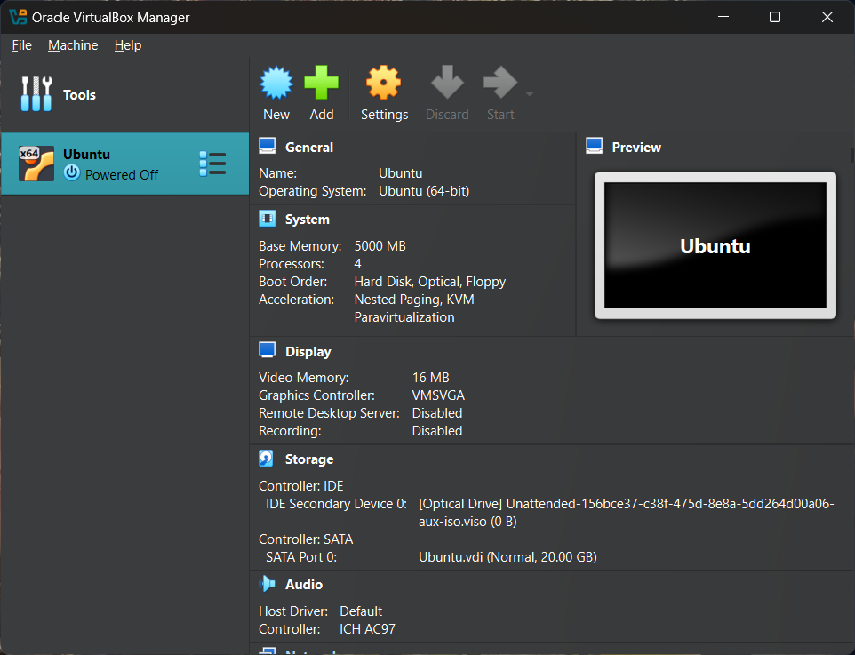

**Conclusion:** In this lab, we successfully installed and configured Oracle VirtualBox to create and manage a virtual machine running Ubuntu. The process involved selecting the appropriate system resources, allocating storage, and completing the OS installation. Hosted hypervisors like VirtualBox offer flexibility in testing different operating systems without affecting the host machine. However, performance may vary based on resource allocation and hardware capabilities. Overall, using virtual machines enhances system efficiency and provides an excellent platform for testing and learning.

**References:**

1. KVM Documentation:

<https://www.linux-kvm.org/page/Main_Page>

2. VMware Workstation Documentation: <https://www.vmware.com/support/pubs/workstation_pubs.html>

3. VirtualBox Documentation: [[https://www.virtualbox.org/wiki/Documentation](https://www.virtualbox.org/wiki/Documentation)](https://www.virtualbox.org/wiki/Documentation%5D(https://www.virtualbox.org/wiki/Documentation))